PDBTools - Travel Authorization

Name: Braulio Pérez | Start date for travel:

Travel objective: Visit to DMH, Gaby, Sierra Gorda, Centinela

Frequent flyer N° 125803121 | Account N°
Purchase Order | Employee signature  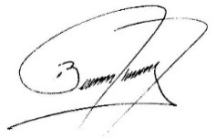

Estimated flight travel expense: CLP$ 263.490

Travel date | From | to | airline | Flight time | Ticket Flexible yes/no
 | Santiago | Calama |  | morning | No
 | Calama | Santiago |  | evening | yes

Estimated lodging/car rental expense: CLP$ 390.000

Hotel/car rental |  | Amount
Diego de Almagro |  | 120.000
Truck rental for 3 days |  | 270.000

Estimated total travel/Accomodation expense: CLP$ 653.490

Approved by ____________________________________ Date _____________________

